Project: AWS Cost Monitoring & Budget Alerts

Services Used:
AWS Budgets, Amazon SNS, AWS Lambda, Amazon SES, Cost Explorer

Description:
This project implements an automated cost monitoring system in AWS that tracks cloud spending and sends real-time email alerts when defined budget thresholds are exceeded. It uses AWS Budgets to monitor usage, SNS to trigger events, Lambda to process alerts, and SES to send email notifications.

Definition:
The AWS Cost Monitoring & Budget Alerts system is designed to monitor AWS billing and notify users when spending crosses predefined thresholds. It integrates AWS Budgets with serverless services to provide automated, real-time alerts and improve cost control.

Scope of the Project:
- Automated cost tracking using AWS Budgets
- Threshold-based alert system (50%, 80%, 100%)
- Real-time notifications using SNS and SES
- Serverless processing using Lambda
- Optional cost insights using Cost Explorer

This Project Covers:
- Budget Monitoring: Tracks AWS usage against a defined budget
- Alert Automation: Sends alerts when thresholds are reached
- Event-Driven Architecture: Uses SNS and Lambda for automation
- Email Notification System: Sends alerts via SES
- Cost Visibility: Provides insights into cloud spending

Methodology:

1. AWS Budgets + SNS + Lambda + SES (Implemented Method)
- Uses AWS managed services
- Fully automated alerting system
- Serverless architecture
- Scalable and cost-effective
- Sends real-time notifications

2. Manual Monitoring + Email Alerts (Alternative Method)
- Uses manual checking of billing dashboard
- No automation
- Delayed response to cost increase
- Not efficient for production environments
- This method was not implemented

AWS Services Used in the Project:

1. AWS Budgets
Definition: AWS Budgets allows users to set custom cost and usage budgets and receive alerts when thresholds are exceeded.
Purpose: Monitor AWS spending
Role: Triggers alerts when budget limits are crossed

2. Amazon SNS (Simple Notification Service)
Definition: A messaging service used to send notifications via multiple protocols like email, SMS, and Lambda triggers.
Purpose: Sends alerts and triggers events
Role: Receives budget alerts and invokes Lambda

3. AWS Lambda
Definition: A serverless compute service that runs code without managing servers.
Purpose: Processes budget alerts
Role: Formats alert messages and sends emails via SES

4. Amazon SES (Simple Email Service)
Definition: A cloud-based email service for sending transactional emails.
Purpose: Send email notifications
Role: Delivers alert emails to users

5. AWS Cost Explorer
Definition: A tool to visualize and analyze AWS costs and usage.
Purpose: Provides cost insights
Role: (Optional) Used by Lambda to fetch detailed spending data
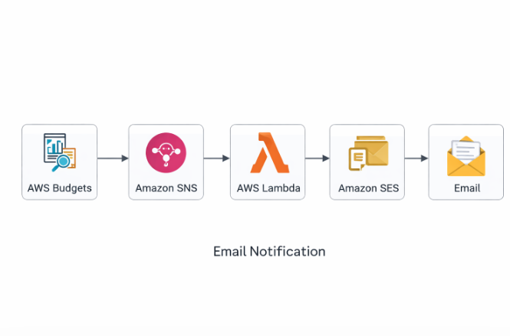

Implementation Steps:

Step 1: Create Budget
- Go to AWS Budgets
- Select Customize (Advanced)
- Choose Cost Budget
- Set monthly budget (e.g., $1 for testing)
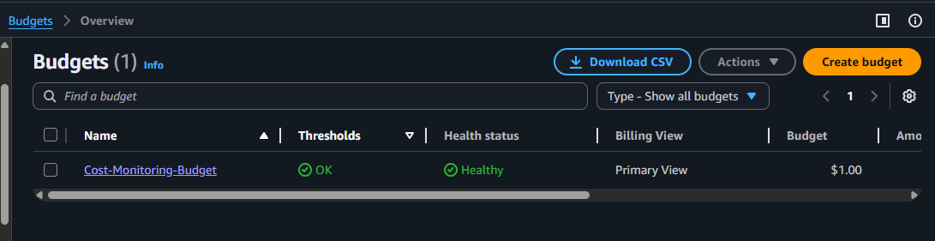

Step 3: Create SNS Topic
- Go to SNS → Create Topic
- Name: budget-alert-topic
- Create email subscription
- Confirm subscription via email
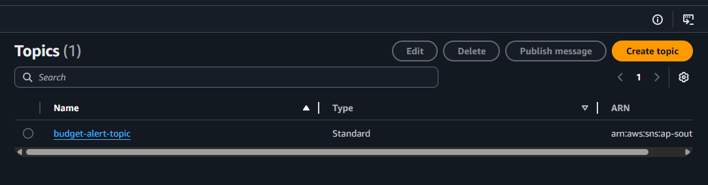
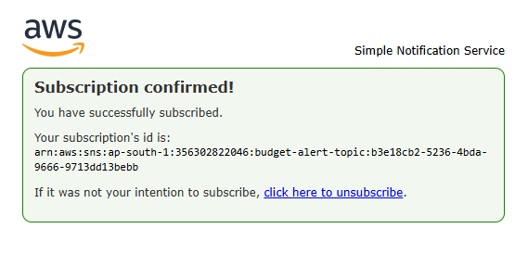

Step 4: Configure SES
- Go to SES → Verified identities
- Verify email address
- Confirm via email link
- Ensure region matches Lambda
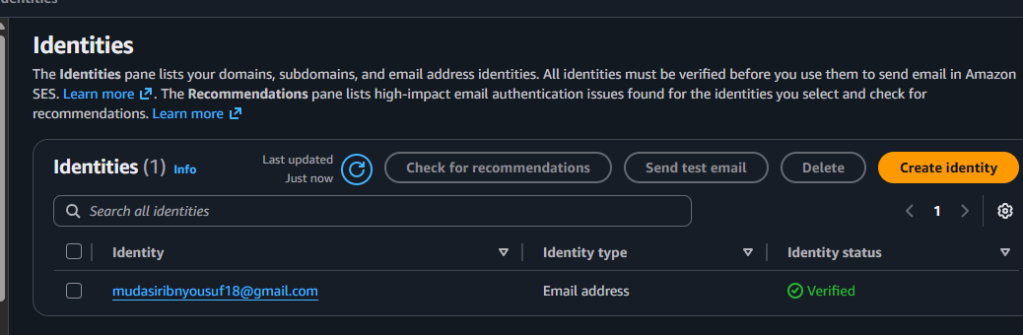

Step 5: Create Lambda Function
- Go to Lambda → Create Function
- Runtime: Node.js
- Function name: budget-alert-handler
- Assign execution role
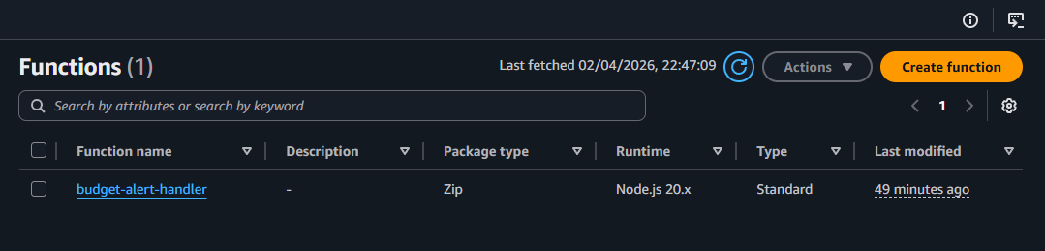

Step 6: Configure Permissions
Attach policies:
- AmazonSESFullAccess
- AWSBillingReadOnlyAccess
- AWSLambdaBasicExecutionRole
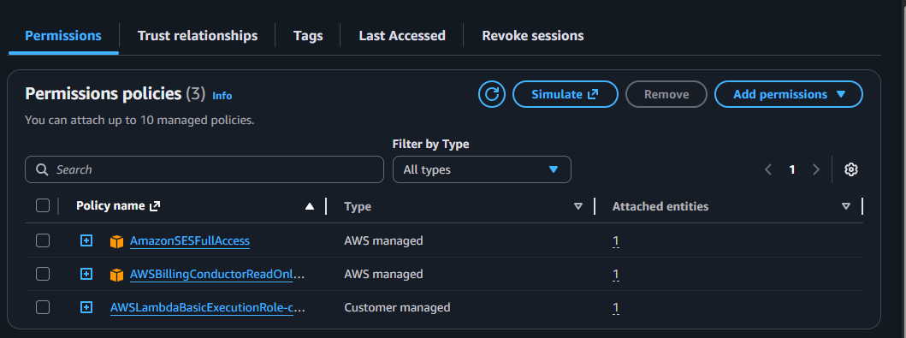

Step 7: Add SNS Trigger
- Add SNS trigger to Lambda
- Select budget-alert-topic
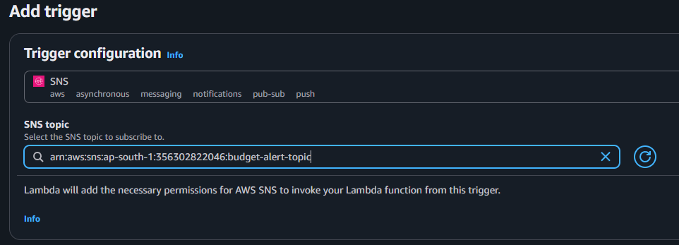

Step 9: Deploy code and Test
- Deploy Lambda code
- Create SNS test event
- Run test
- Verify email received
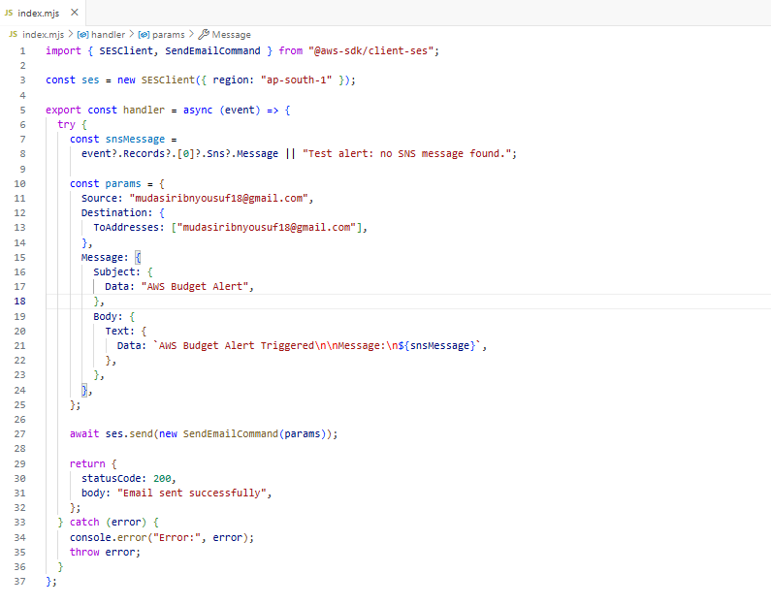
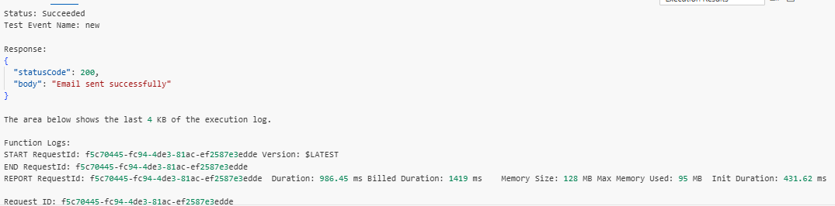

Lambda Function Logic:
- Receive SNS event
- Extract budget alert message
- Format notification message
- Send email using SES
- Handle errors and log output
Cost Monitoring:
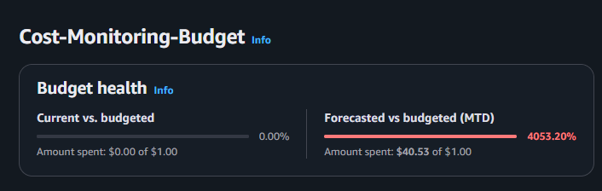

Left side:
- Actual spend: $0.00 / $1.00
You have not used any cost yet

Right side (IMPORTANT):
- Forecasted spend: $40.53 / $1.00
AWS is predicting you may spend $40 this month

Why No Notification Was Triggered
The budget alert was not triggered because notifications are configured based on actual spending, not forecasted spending.
At the time of observation:
- Actual Spend: $0.00
- 50% Threshold Value: $0.50
Since the actual spend ($0.00) is below the defined threshold ($0.50), the alert condition has not been met.

Troubleshooting:

Issue 1: Email not sending
Cause: Email not verified in SES
Solution: Verify email in SES and confirm via inbox

Issue 2: Region mismatch
Cause: SES and Lambda in different regions
Solution: Ensure both are in same region (e.g., ap-south-1)

Issue 3: Lambda test error (SNS format)
Cause: Incorrect test event format
Solution: Use SNS event structure

Issue 4: Permissions error
Cause: Missing IAM permissions
Solution: Attach required policies to Lambda role

Conclusion:
This project successfully demonstrates an automated AWS cost monitoring system that tracks usage and sends real-time alerts when budget thresholds are exceeded. By integrating AWS Budgets, SNS, Lambda, and SES, the system ensures efficient cost control, reduces manual monitoring, and provides a scalable serverless solution suitable for real-world applications.

